12주차 실습과제

20135151 이갑성

1번

**import** java.util.Arrays; //자바에서 제공하는 메소드가 저장되 있는 빵틀

**public** **class** Arraysort {

**public** **static** **void** main(String args[]) **throws** Exception {

**int** array[] = { 2, 5, -2, 6, -3, 8, 0, -7, -9, 4 };

//Arrays.sort(array, 2, 7);

Arrays.*sort*(array); // 정렬

*printArray*("Sorted array", array);

**int** index = Arrays.*binarySearch*(array, 4); //이진탐색

System.***out***.println("Found 4 @ " + index); //4가 몇번방에 있나?

}

**private** **static** **void** printArray(String message, **int** array[]) {

System.***out***.println(message + ": [length: " + array.length + "]");

**for** (**int** i = 0; i < array.length; i++) {

**if**(i != 0){

System.***out***.print(", ");

}

System.***out***.print(array[i]);

}

System.***out***.println();

}

}

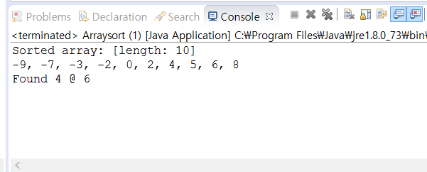

2번

**public** **class** ShellSort {

**public** **static** **void** main(String[] args) {

**int** array[] = { 2, 5, -2, 6, -3, 8, 0, -7, -9, 4 };

*shellSort*(array);

System.***out***.println("Sorted array: ");

**for**(**int** i = 0; i < array.length; i++)

{

System.***out***.print(array[i] + " ");

}

}

**public** **static** **void** shellSort(**int**[] a) {

**int** interval = a.length;

**while** (interval > 1) {

interval = 1 + (interval / 3);

**for** (**int** i = 0; i < interval; i++) {

*intervalSort*(a, i, interval);

}

}

}

**private** **static** **void** intervalSort(**int**[] a, **int** i, **int** interval) {

**int** j = i + interval;

**int** newValue, k;

**boolean** move;

**while** (j < a.length) {

move = **true**;

newValue = a[j];

k = j;

**while** (move) {

**if** (a[k - interval] <= newValue) {

move = **false**;

} **else** {

a[k] = a[k - interval];

k = k - interval;

**if** (k == i) {

move = **false**;

}

}

}

a[k] = newValue;

j = j + interval;

}

}

}

